Copulas: GBPUSD and USDCHF
Method 18 / daily log returns / empirical ranks / Gaussian + Clayton / Alpari D1 full available history

Study setup
Logical pair: GBPUSD , USDCHF
Broker symbols: GBPUSD_i , USDCHF_i
Snapshot: 2026-11-03_majors_alpari_D1
Timeframe: D1
Matched return window: 1999-01-05 to 2026-11-02 (UTC bar dates)
Matched return count n: 7201
Dropped unfinished last bar dated 2026-11-03 UTC after a tick-volume check against the prior complete day.
Margins: empirical ranks / (n+1)
Families: Gaussian (rho) and Clayton (theta), fixed before ranking
Complete matched rows (Excel): GBPUSD-USDCHF_Copula_D1.xlsx
Complete matched rows (HTML table): GBPUSD-USDCHF_Copula_D1_data.html

Method carried forward
Copulas separate marginal return shapes from dependence on the unit square. Matched daily log returns of close, ln(close_t / close_t-1), are mapped to pseudo-observations u_i = rank(x_i)/(n+1) and v_i = rank(y_i)/(n+1). A Gaussian copula parameter rho is the Pearson correlation of Phi^{-1}(u) and Phi^{-1}(v). A Clayton copula theta >= 0 is fit by maximum likelihood on (u,v) for lower-tail asymmetry. Quotes are not inverted. Kendall tau implied by each fit and Spearman of (u,v) are stored. Same-sample Pearson r on returns is a side check. This is not causation and not a trading signal.

Results
Gaussian rho: -0.553528
Gaussian Kendall tau: -0.373438
Clayton theta: 0.000000
Clayton Kendall tau: 0.000000
Spearman of (u,v): -0.551519
Pearson r on returns: -0.486083

Conclusion
Over 7201 matched daily rows for GBPUSD and USDCHF, Gaussian copula rho = -0.5535 (Kendall=-0.3734) and Clayton theta = 0.0000 (Kendall=0.0000). Spearman of (u,v) = -0.5515; Pearson r on returns = -0.4861. This is not causation and not a trading signal.

Charts
Daily closes

Daily log returns

Pseudo-observations (u,v)
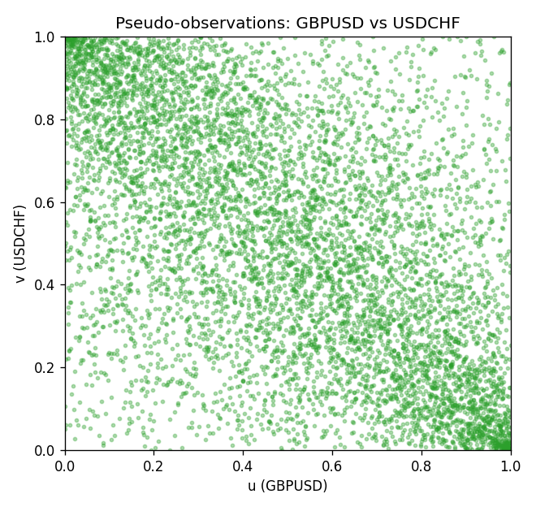

Data report
Every matched row is stored in the sibling Excel workbook named GBPUSD-USDCHF_Copula_D1.xlsx, including u and v. Embedding all rows as a Word table is impractical; this file holds column summaries and the first and last 15 matched rows.
Columns: time, GBPUSD_open, USDCHF_open, GBPUSD_high, USDCHF_high, GBPUSD_low, USDCHF_low, GBPUSD_close, USDCHF_close, GBPUSD_tick_volume, USDCHF_tick_volume, GBPUSD_spread, USDCHF_spread, GBPUSD_real_volume, USDCHF_real_volume, GBPUSD_log_return, USDCHF_log_return, u, v
Column summaries (matched calculation rows)
column | count | mean | std | min | 25% | 50% | 75% | max
GBPUSD_open | 7201 | 1.5160785 | 0.218271 | 1.06854 | 1.32499 | 1.51142 | 1.63167 | 2.1066
USDCHF_open | 7201 | 1.0982956 | 0.25264095 | 0.72022 | 0.92069 | 0.99019 | 1.2387 | 1.8219
GBPUSD_high | 7201 | 1.5223771 | 0.21884011 | 1.08366 | 1.32979 | 1.5182 | 1.6384 | 2.1161
USDCHF_high | 7201 | 1.1035944 | 0.25438893 | 0.73305 | 0.92495 | 0.99377 | 1.2436 | 1.8313
GBPUSD_low | 7201 | 1.5097512 | 0.21749696 | 1.03518 | 1.31949 | 1.50336 | 1.6244 | 2.0983
USDCHF_low | 7201 | 1.0931703 | 0.25105533 | 0.08565 | 0.91742 | 0.9867 | 1.2331 | 1.8121
GBPUSD_close | 7201 | 1.5161456 | 0.2182303 | 1.06879 | 1.3251 | 1.5114 | 1.63212 | 2.1065
USDCHF_close | 7201 | 1.0982864 | 0.25254184 | 0.72025 | 0.92098 | 0.9902 | 1.2387 | 1.8217
GBPUSD_tick_volume | 7201 | 94828.085 | 153546.21 | 62 | 10002 | 52900 | 91806 | 1273370
USDCHF_tick_volume | 7201 | 74189.26 | 113409.95 | 18 | 12770 | 40195 | 70240 | 858589
GBPUSD_spread | 7201 | 26.971115 | 19.193539 | 0 | 11 | 20 | 50 | 50
USDCHF_spread | 7201 | 26.114567 | 24.723753 | 0 | 5 | 16 | 50 | 100
GBPUSD_real_volume | 7201 | 3.5560898e+09 | 8.4438214e+10 | 0 | 0 | 0 | 0 | 2.4038164e+12
USDCHF_real_volume | 7201 | 2.3236557e+10 | 8.9041498e+10 | 0 | 0 | 0 | 0 | 1.9331921e+12
GBPUSD_log_return | 7201 | -2.316e-05 | 0.00564524 | -0.08388241 | -0.00312969 | 3.242e-05 | 0.00318104 | 0.03112653
USDCHF_log_return | 7201 | -7.148e-05 | 0.00659332 | -0.19545699 | -0.00335964 | 8.06e-05 | 0.00331782 | 0.09051364
u | 7201 | 0.5 | 0.28865509 | 0.00013885 | 0.25006943 | 0.5 | 0.74993057 | 0.99986115
v | 7201 | 0.5 | 0.28865509 | 0.00013885 | 0.25006943 | 0.5 | 0.74993057 | 0.99986115
First 15 matched rows (selected columns)
time | GBPUSD_log_return | USDCHF_log_return | u | v
1999-01-05 | -0.0028966287 | 0.0039424743 | 0.26617606 | 0.7836712
1999-01-06 | -0.00060452184 | 0.013605652 | 0.44168287 | 0.98375451
1999-01-07 | -0.002118709 | -0.0093883841 | 0.32102194 | 0.058733685
1999-01-08 | -0.0058954193 | 0.011040268 | 0.11816162 | 0.96695362
1999-01-11 | -0.0056851331 | 0.0052963193 | 0.12510414 | 0.84490419
1999-01-12 | 0.0022657001 | -0.0098275602 | 0.68897528 | 0.052624271
1999-01-13 | 0.0091330396 | -0.018259701 | 0.95459595 | 0.0058317134
1999-01-14 | 0.0019376331 | -0.0024256692 | 0.66189947 | 0.30505415
1999-01-15 | -0.0017558204 | 0.01794228 | 0.34837545 | 0.99486254
1999-01-18 | 0.0012112405 | -0.0031856384 | 0.60399889 | 0.2593724
1999-01-19 | 0.0018745281 | -7.2518946e-05 | 0.65620661 | 0.48625382
1999-01-20 | -0.0049053846 | 0.0072259871 | 0.15648431 | 0.90780339
1999-01-21 | 0.0031518998 | -0.0038232689 | 0.74770897 | 0.22702027
1999-01-22 | 0.0024781662 | -0.0001445609 | 0.70397112 | 0.4798667
1999-01-25 | 0.0012066366 | 0.0024546976 | 0.60358234 | 0.69119689
Last 15 matched rows (selected columns)
time | GBPUSD_log_return | USDCHF_log_return | u | v
2026-10-13 | 0.0036434319 | -0.0024955621 | 0.77728409 | 0.30019439
2026-10-14 | -0.0049164679 | 0.0029388325 | 0.15592891 | 0.72507637
2026-10-15 | 0.0065976411 | -0.0097855323 | 0.90336018 | 0.053596223
2026-10-16 | 0.0037592051 | -0.0036230826 | 0.78408775 | 0.238406
2026-10-19 | -0.0017500314 | 0.0036351779 | 0.34948625 | 0.76798112
2026-10-20 | 0.0055923442 | -0.0026281224 | 0.8703138 | 0.29214107
2026-10-21 | 0.0012476328 | -0.00040027413 | 0.6067759 | 0.45598445
2026-10-22 | 0.00022396082 | -0.0048036381 | 0.51818939 | 0.18397667
2026-10-23 | -0.0021146949 | 0.005652514 | 0.32157734 | 0.86017773
2026-10-26 | -0.0024340661 | 0.0018407959 | 0.29713968 | 0.64343238
2026-10-27 | -0.0023648393 | 0.0026100526 | 0.30227715 | 0.70091641
2026-10-28 | 0.0015771808 | -0.0010142111 | 0.63371286 | 0.40808109
2026-10-29 | 0.0035881935 | -0.0048680164 | 0.77506248 | 0.18092197
2026-10-30 | 0.0013450605 | 0.00071594559 | 0.61469036 | 0.55387392
2026-11-02 | 0.0010971256 | -0.0071459744 | 0.59455707 | 0.10302694

